SERIAL COMMUNICATIONS
- Communication protocols that exchange data can be separated into two categories: parallel or serial
- Parallel sends multiple bits at the same time - fastest but requires multiple pins
- Serial sends them one at a time - requires only one pin
- USB (Universal Serial Bus) is a form of serial communication
- Allows for the communication between different peripheral devices like mice, digital cameras, printers, keyboards, media devices, scanners, flash drives & external hard drives as well as a host controller like a smartphone or PC
- This is known as USB protocol
- Has 4 pins:
  - Pin1 (VBUS): It is a red color wire, used for providing power supply.
  - Pin2 (D-): It is a differential pair pin available in white color, used for connectivity of USB.
  - Pin3 (D+): It is a differential pair pin available in green color, used for connectivity of USB.
  - Pin4 (GND): It is a Ground pin, available in black color.
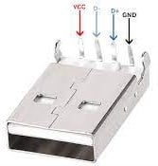
- Link to USB Protocol: https://www.elprocus.com/usb-protocol/
- BAUD rate = speed of data sent, too fast will begin seeing errors
- Synchronization Bit = start and stop bit
- Parity Bit = low-level error checking
- UART (Universal Asynchronous Receive/Transmit) On QPG6200L chip
  - Full-duplex communication protocol, as its asynchronous nature allows both transmitters to send at the same time
  - Uses TTL (transistor-transistor logic) level - tells which voltage levels are 1s and 0s
  - Baud rates from 488 Bd to 2 MBd
  - Serial frames with 5, 6, 7, 8 or 9 data bits and 1 or 2 stop bits, with framing error detection
  - Odd or even parity generation and checking
  - Buffer overflow detection
  - False start bit detection and digital low pass filter for robustness against noise
  - The QPG6200L can provide two clocks to peripheral devices (CLK_OUT). The clock frequency is derived from the 192 MHz crystal oscillator system clock. It can be configured for frequencies up to 96 MHz
  - RX and TX may need to be may need their jumpers switched for UART to work
  - UART registers and associated pins
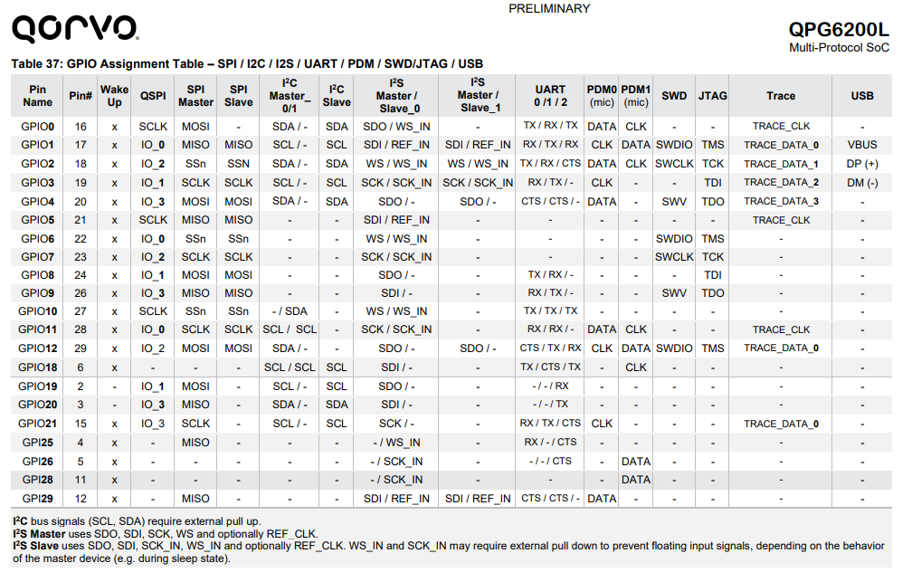
- I2C (Inter-Integrated Circuit) vs I2S (Inter-IC Sound)
  - I2C is a two-wire serial communication protocol for connecting various peripherals like sensors and memory, used for control and configuration.
  - I2S (Inter-IC Sound) is a single-direction serial interface designed specifically for high-speed transmission of digital audio data between audio devices like codecs and digital signal processors.
  - I2S uses a shared clock signal to synchronize the data transmission between devices and transmits audio in a serial fashion
  - While I2C handles control and management, I2S efficiently transfers audio
  - I2C has three connections:
    - the clock signal (SCK) for synchronizing communication partners
    - a word select (WS) line for switching between the left and right audio channels
    - a dedicated data wire exclusively for transmitting audio information bit-by-bit
  - The two protocols are often used together in audio systems, where I2C configures devices and I2S carries the actual audio stream
  - Intended to allow multiple “slave” chips to communicate with one or more “master” chips
  - I2C is half duplex, slaves cannot communicate with master
  - Using unique address for each device helps control where to data goes to
  - Need to have pull-up resistors
  - Intended for short distance communications within a single device
  - I2S Link: https://www.digikey.com/en/maker/tutorials/2023/what-is-the-i2s-communication-protocol
  - SPI is similar to I2C, however there’s some key differences
    - It is full duplex as there’s a two way communication involving 2 wires
    - It’s very fast at sending (high data rate)
    - It can support multiple devices, however it will require more wiring for each device. I2C only uses 1 line to communicate to which device to use
- PDM (Pulse-Density Modulation)
  - There are two of these PDM MEMS Microphone interfaces on the QPG6200L (PDM0 and PDM1)
  - It provides conversion from a Pulse Density Modulated signal (PDM), which is typically used for low-cost digital microphones, to a 16-bit Pulse Code Modulated signal (PCM).
  - It has:
    - A Clock and Data pin for interfacing with a PDM MEMS microphone.
    - Optionally Capturing Data on the Rising and Falling Edge of the Clock for Stereo operations.
    - Configurable frequency of Clock signal:
      - Default = 2 MHz
      - Digital frequency synthesizer for generating frequencies up to 3072 kHz.
  - Any of the Data GPIOs can be used as an input from the selected microphone
  - If need to configure the clock signal in the case 2MHz is not applicable, use one of the GPIOs below
  - May use the microphone for simple applications (i.e. command for playing something on the audio speaker)
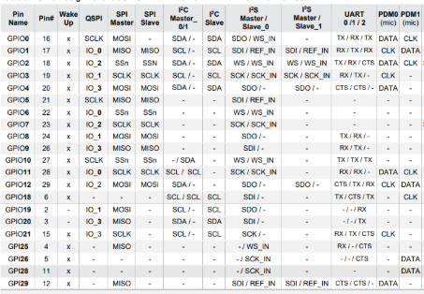
- PWM (Pulse-Width Modulation)
  - The QPG6200L contains a PWM (Pulse-Width Modulation) peripheral.
  - The PWM peripheral enables the generation of 16-bit pulse width modulated signals on an assigned GPIO.
  - The main features of the PWM peripheral are:
    - Programmable PWM frequency
    - Up to 8 PWM channels, each with an independent phase and duty cycle
    - Arbitrary waveform generation driven by RAM defined sequences
    - Glitch free parameter updates
  - Used for control the speed of motors and the brightness of LEDs, the position of servo motors, and the loudness/volume of buzzers/speakers
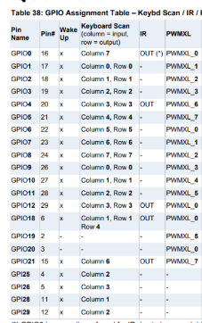

- ADC’s
  - Environmental Monitoring: Reading temperature, humidity, or light levels from sensors.
  - Audio: Capturing sound, though high-quality applications require high-speed ADCs
  - User Interfaces: Interpreting inputs from potentiometers or other analog controls.
  - Sensors and Automation: Reading sensor data to control motors and other actuators
